

CAPSTONE PROJECT REPORT
Report 1 – Project Introduction

– Danang, August 2025 –
Table of Contents
I. Record of Changes 3
II. Project Introduction 4
1. Overview 4
1.1 Project Information 4
1.2 Project Team 4
2. Product Background 4
3. Existing Systems 5
3.1 MyFPTSchools 5
3.2 iSchoolBus 6
4. Business Opportunity 6
5. Software Product Vision 8
6. Project Scope & Limitations 8
6.1 Major Features 8
6.2 Limitations & Exclusions 9

I. Record of Changes
Date | A*  M, D | In charge | Change Description
06/09/2025 | A | NhiPTK | Create the project introduction document
06/09/2025 | A | NhiPTK | Add content for II.1, II.2, II.3, II.4, II.5
09/09/2025 | A | KhoiVN | Add the project scope & limitations
10/11/2025 | M | All | Update product background
*A - Added M - Modified D - Deleted

II. Project Introduction

1. Overview

1.1 Project Information
- Project name: Building a school bus management system for educational institutions using ReactJS, and ASP.NET
- Project code: EduBus
- Group name: SE_01
- Software type: Web, Mobile App

1.2 Project Team
Full Name | Role | Email | Mobile
Nguyen Thi Thuy Hoai | Lecturer | hoaintt40@fe.edu.vn | 0982827763
Phan Thai Khanh Nhi | Leader | nhiptkde180931@fpt.edu.vn | 0901984129
Nguyen Le Quang Huy | Member | huynlqde170716@fpt.edu.vn | 0763761165
Nguyen Thi Thu Nguyet | Member | nguyetnttde170280@fpt.edu.vn | 0376994321
Vuong Nguyen Khoi | Member | khoivnde180905@fpt.edu.vn | 0916314778
Nguyen Viet Thanh Trung | Member | trungnvtde170677@fpt.edu.vn | 0385282972

2. Product Background
In many schools today, attendance on and off the bus is still recorded manually—either in paper logbooks or simple spreadsheets. This manual process is prone to human error such as missed check-ins, incorrect names, or misplaced records. As a result, schools and parents often lack real-time visibility into a bus’s location during pick-up and drop-off times, leading to anxiety, unnecessary phone calls, and delays. Meanwhile, drivers and administrative staff can spend 15–20 minutes each morning and afternoon just compiling, verifying, and reconciling attendance lists, reducing overall operational efficiency.
Key user groups:
- Parents: Require instant updates when their child boards or leaves the bus, real-time vehicle location, and delay alerts so they can plan pick-up and drop-off accordingly.
- School Administrators: Need comprehensive trip reports, daily attendance summaries, and timely alerts for any incidents (e.g., late arrivals, route deviations).
- Drivers & Supervisors: Seek an intuitive interface for managing daily routes, reporting unexpected events (traffic jams, vehicle issues), and submitting quick status updates.
- Students: Benefit from improved safety, minimized attendance mistakes, and smoother transportation experience without delays or miscommunication.
EduBus addresses this gap by integrating facial-recognition technology to automatically record each student’s boarding and alighting event, eliminating manual entry and preventing “forgotten” or falsified records. Real-time GPS integration displays precise bus location and speed on an interactive digital map, enabling parents and administrators to monitor routes live and receive automated alerts if a bus is running behind schedule or deviates from its planned path. Push notifications inform all stakeholders of key events, such as “Bus has arrived at pick-up point,” “Student has disembarked,” or “Bus delayed due to traffic.”

Additionally, a built-in service registration and online payment module allows parents to reserve seats, calculate fees based on distance and time, and complete secure transactions without visiting the school in person. A reporting and analytics engine automatically generates daily and monthly summaries of ridership, route performance metrics, and historical logs, empowering school leaders to make data-driven decisions for cost optimization and service improvement.
In summary, EduBus was conceived to eliminate:
- Errors and delays are inherent in manual record-keeping.
- Lack of transparency around bus location and status.
- Fragmented communication among parents, drivers, and school staff.
- Time-consuming reporting processes that hinder decision-making.
By unifying facial recognition, real-time GPS tracking, instant notifications, and automated reporting within a single platform, EduBus enhances student safety, streamlines operations, and delivers a seamless experience for all stakeholders.

3. Existing Systems

3.1 MyFPTSchools
Mobile app download link:
- Google Play: https://play.google.com/store/apps/details?id=com.myfptschool&hl=en
- App Store: https://apps.apple.com/id/app/myfptschools/id1573857025
- System Actors
- Parents: Primary users who install the app, log in with their registered phone number, select their child (or children), and access all student-related information and services.
- Students: Indirect actors—parents view and manage their child’s academic and attendance data; students can also access the app directly to review their own schedule and assignments.
- Teachers & School Staff: Author and publish all academic content (grades, homework, disciplinary notes), manage clubs and events, process leave requests, and send notifications through the system.
- School Administrators: Oversee user accounts, system settings, and high-level reporting; ensure data integrity and service availability.
- IT Support: Maintain the backend (FSP portal integration), handle version upgrades, and troubleshoot installation or login issues.
- Main features
- Announcements & Notifications (push)
- Digital Gradebook with detailed score breakdowns
- Attendance Tracking for classes and dorms
- Dormitory Management (room assignments, boarding status)
- Interactive Timetables
- In-App Messaging between parents, students, and staff
- News Feed & Event Calendar
- Club Directory & Sign-Ups
- Rewards & Discipline Records
- Advantages
- All-in-One Educational Hub: Consolidates academic records, attendance, communications, extracurriculars, and billing into a single intuitive interface.
- Real-Time Updates: Push notifications and in-app alerts keep parents and staff informed instantly.
- Disadvantages
- Limited Scope: Focuses solely on FPT Schools; not configurable for other institutions.

3.2 iSchoolBus
- System Actors
- Fleet Managers / Dispatchers – configure routes, assign vehicles and drivers, monitor status and incident alerts
- Drivers – receive optimized routes, report incidents, and view passenger manifests
- Parents – track bus location in real time, receive delay or incident notifications, and provide feedback
- Students – use the feedback channel to report service issues or incidents
- Main features
- Real-Time Incident Alerts – traffic jams, unauthorized stops, route deviations
- Smart Route Optimization – advanced algorithms for efficient routing with manual override
- Visual Fleet Dashboard – manage vehicle list, registered student manifests, on-route student status, drivers, and routes
- Online Communication Channel – collect parent/student feedback directly in the app
- GPS Tracking & Mapping – live bus location and map search (requires location permission)
- Advantages
- Enhanced Safety & Responsiveness via instant incident alerts and deviation warnings
- Operational Efficiency through automated route planning and centralized fleet management
- User Feedback Loop – direct in-app channel for service improvement suggestions
- Disadvantages

4. Business Opportunity
Market Trends and Fit
- Broader EdTech Momentum: Education technology is evolving from isolated classroom tools to enterprise-grade platforms, driving schools to adopt cloud-based, AI-enabled solutions for all aspects of their operations, including transportation.
- Extension of Digital Workflows: As schools digitize attendance, grading, and communication, there is a natural extension into student transport, demanding the same level of real-time visibility and automation for bus services.
- Convergence on Unified Platforms: Stakeholders increasingly favor integrated systems that bring academic, administrative, and operational functions under one roof, reducing tool-sprawl and simplifying user experience.
Solving Key Problems
- Error-Prone Manual Processes: Traditional paper logs and spreadsheets lead to data gaps and time-consuming reconciliation. EduBus automates boarding/alighting and attendance, ensuring accuracy and freeing staff for higher-value tasks.

- Limited Visibility & Safety Concerns: Without live tracking, parents and administrators lack reassurance. EduBus’s GPS telematics and geofenced alerts deliver continuous location updates and instant notifications, bolstering student safety.
- Fragmented Communication: Multiple channels (calls, SMS, email) create delays and information loss. EduBus centralizes messaging and alerts in one app, ensuring all parties receive the right information at the right time.
- Inefficient Routing & Operations: Static routes and reactive maintenance inflate costs and risk service disruptions. EduBus’s intelligent routing engine and maintenance dashboard optimize fleet utilization and anticipate issues before they arise.
Key Features and Benefits

Feature | Benefit
Real-Time GPS Tracking | Continuous bus location visibility; peace of mind for parents and admins.
Automated Attendance (Facial-recognition) | Tamper-proof, hands-free boarding records eliminate manual errors.
Route Optimization | Smarter routing reduces travel time, fuel use, and operational expense.
Self-Service Registration & Payment | Simplified seat booking and secure online payment without on-site visits.
Reporting & Analytics | Actionable insights on ridership trends, route performance, and costs.

Market Needs and Opportunities
- Digital Transformation Imperative: Schools are under pressure to modernize beyond classroom tech, extending digital workflows to all school operations for efficiency and transparency.
- Heightened Safety & Compliance: Rising safety standards and community expectations make real-time monitoring and automated attendance solutions mission-critical for districts.
- Specialized Transport Services: Niche requirements (e.g., special-needs shuttles, multi-modal fleets) demand flexible platforms that legacy systems cannot easily support.
- Integration Challenges: Many districts struggle with high integration costs and complexity when linking disparate routing, attendance, and maintenance systems; a unified SaaS platform simplifies deployment and management.
- Modular Growth Path: By offering core capabilities with optional premium modules—advanced analytics, AI optimization, and white-labeling—EduBus can serve small private schools and large districts alike, driving adoption across diverse educational contexts.

5. Software Product Vision
For parents, school administrators, drivers, and dispatchers who need a secure, transparent, and efficient way to manage student transportation, EduBus is an all-in-one, cloud-based platform designed to enhance safety, streamline operations, and foster clear communication.
EduBus empowers users with:
- Automated Attendance: Facial-recognition boarding and alighting logs that eliminate manual check-ins and ensure tamper-proof records.
- Real-Time GPS Tracking: Live bus location and route visualization on an interactive map, giving parents and staff up-to-the-minute visibility.
- Instant Notifications: Push, SMS, and email alerts for key events—“Bus arriving,” “Student disembarked,” or “Route delay”—so everyone stays informed.
- Dynamic Route Management: AI-driven route optimization with manual override, enabling dispatchers to adjust schedules on the fly for traffic or special needs.
- Self-Service Registration & Payments: Online seat reservations with distance-based fee calculation and secure payment processing, reducing administrative overhead.
- Comprehensive Dashboards: Role-based views for administrators, drivers, and parents—complete with reporting and analytics on ridership trends, fleet utilization, and service performance.
By uniting attendance, tracking, scheduling, communications, and billing in one intuitive web and mobile application, EduBus not only elevates student safety but also drives operational excellence and strengthens trust among all stakeholders. This platform meets evolving market demands for digital transformation in education, aligns with institutional goals for transparency and efficiency, and positions EduBus as the go-to solution for modern school-bus management.

6. Project Scope & Limitations
The EduBus platform aims to digitise and streamline school transportation management, replacing manual processes with a secure, real-time, cloud-based system accessible via both web and mobile interfaces. The system serves four main user groups: school administrators, fleet managers/dispatchers, drivers, and parents. Its goal is to ensure student safety, operational efficiency, and transparent communication.
This section outlines the key features to be developed in the initial release, along with limitations that set realistic expectations for stakeholders and help manage change requests.

6.1 Major Features
FE-01: Real-Time GPS Tracking of school buses with live map view for parents and administrators.
FE-02: Automated Student Attendance using facial-recognition technology when boarding and alighting buses.
FE-03: Dynamic Route Management with AI-driven route optimisation and manual override options for dispatchers.
FE-04: Incident Reporting & Instant Notifications to stakeholders via push, SMS, or email alerts.
FE-05: Self-Service Portal for parents to register students, reserve seats, and make secure online payments based on distance.
FE-06: Visual Fleet Dashboard for administrators to manage vehicles, drivers, routes, and real-time trip status.
FE-07: Reporting & Analytics Engine generating daily/monthly summaries on ridership, performance, and route efficiency.
FE-08: In-App Feedback Channel allowing parents and students to report issues or suggest improvements.
FE-09: Role-Based Dashboards providing tailored views and functionality to each user group.
FE-10: Geo-fencing Alerts that notify administrators and parents when buses deviate from assigned routes or reach key checkpoints.
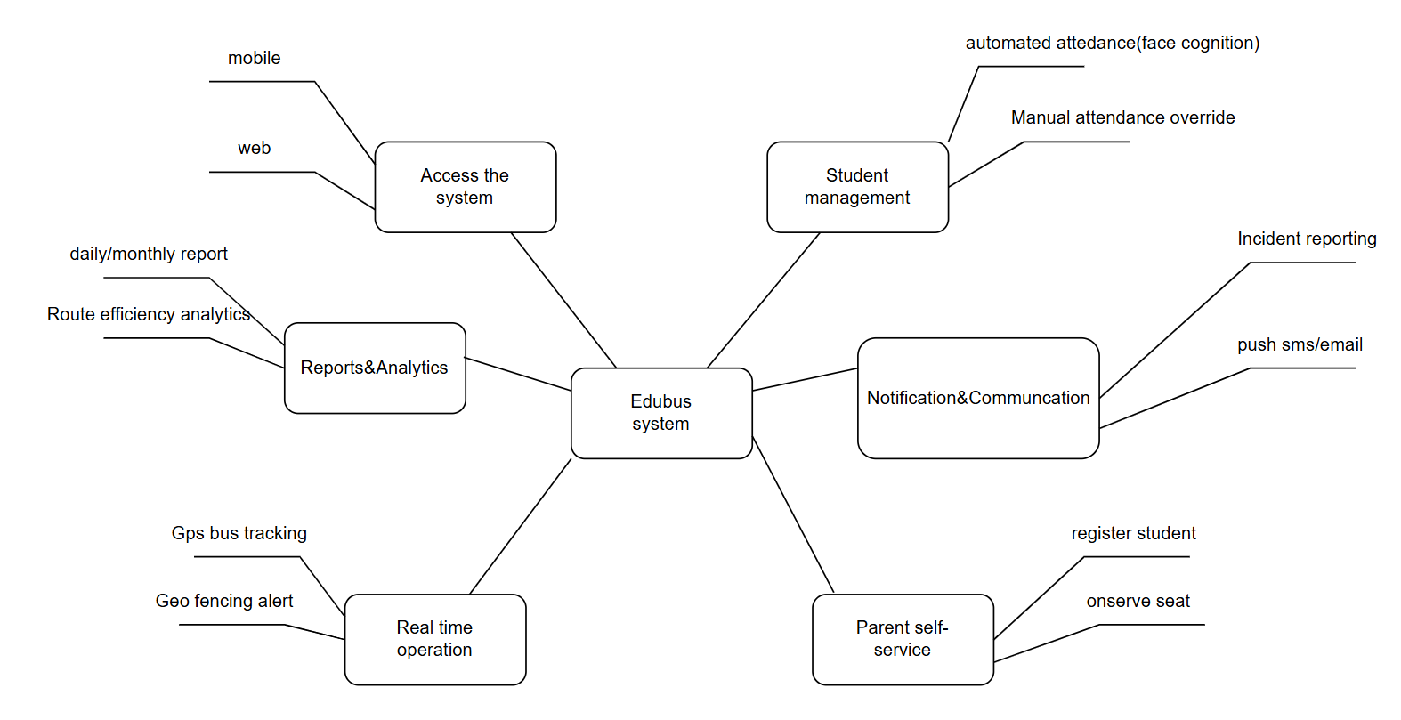

6.2 Limitations & Exclusions
LI-01: Integration with third-party Student Information Systems (SIS) or existing school ERP platforms is not included in this release.
LI-02: Facial-recognition accuracy is dependent on lighting conditions and camera hardware; fallback mechanisms (e.g., manual check-in) are not yet automated.
LI-03: No offline mode will be supported for GPS tracking or attendance; internet connectivity is required for all real-time features.
LI-04: The initial version is limited to standard bus routes and does not support complex transport arrangements such as multi-modal or special-needs routing.
LI-05: EduBus will initially support English only; multilingual support is planned for future versions.
LI-06: The payment module will be limited to a single local payment gateway; support for international gateways or multi-currency is excluded.
LI-07: Push notification support will be available for Android only in the initial mobile release; iOS support will follow in a future phase.
LI-08: Vehicle maintenance scheduling and diagnostics are not part of the current scope.

